Clack Part 3 Tests

**TEST 1:**

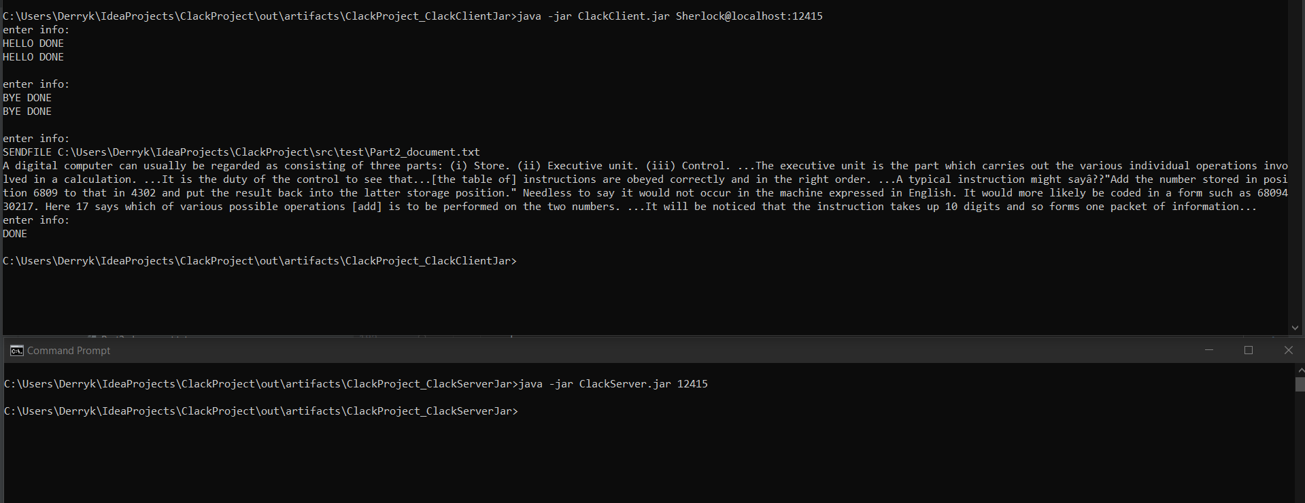

This test case was using localhost and a port number of 12415 to test the SENDFILE, SEND MESSAGE, and DONE (end communication) commands.

**TEST 2:**

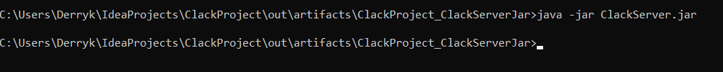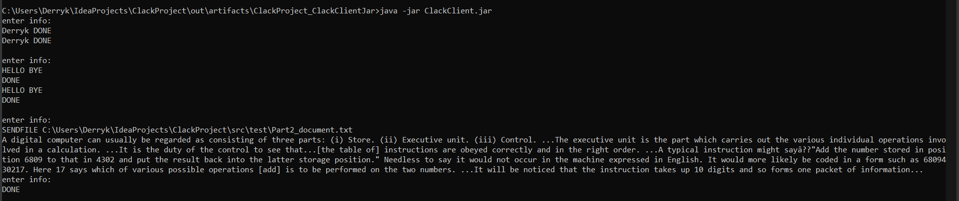

This tested the same options as test 1 except it gave no arguments for both running ClackClient and ClackServer.

**TEST 3:**

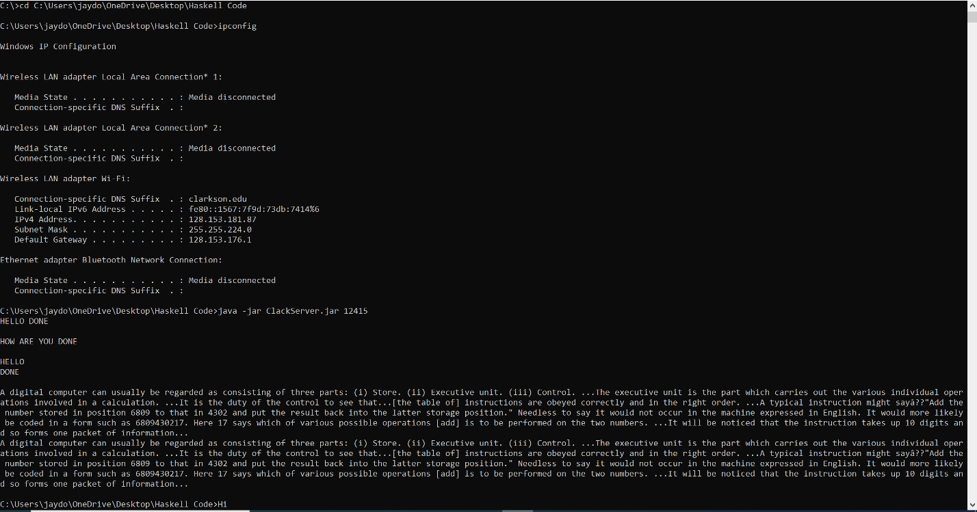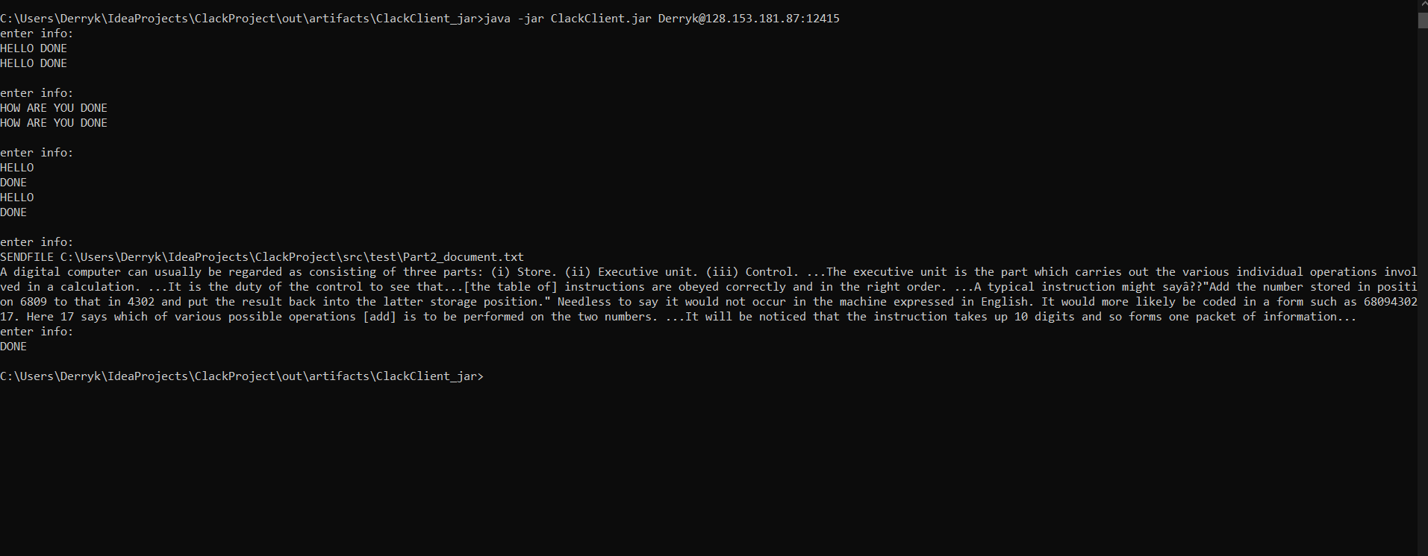

This tested communication between two computers. Test cases were done with both computers acting as a client and a server and outcomes were the same. All 3 options, sending files, sending messages, and ending communication, were tested and successful.